The Legend of St. George and the Dragon
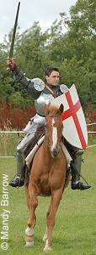
St. George travelled for many months by land and sea until he came to Libya. Here he met a poor hermit who told him that everyone in that land was in great distress, for a dragon had long ravaged the country.
'Every day,' said the old man, 'he demands the sacrifice of a beautiful maiden and now all the young girls have been killed. The king's daughter alone remains, and unless we can find a knight who can slay the dragon she will be sacrificed tomorrow. The king of Egypt will give his daughter in marriage to the champion who overcomes this terrible monster.'
When St. George heard this story, he was determined to try and save the princess, so he rested that night in the hermit's hut, and at daybreak set out to the valley where the dragon lived. When he drew near he saw a little procession of women, headed by a beautiful girl dressed in pure Arabian silk. The princess Sabra was being led by her attendants to the place of death. The knight spurred his horse and overtook the ladies. He comforted them with brave words and persuaded the princess to return to the palace. Then he entered the valley.
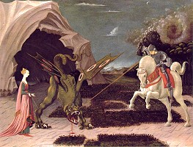
As soon as the dragon saw him it rushed from its cave, roaring with a sound louder than thunder. Its head was immense and its tail fifty feet long. But St. George was not afraid. He struck the monster with his spear, hoping he would wound it.
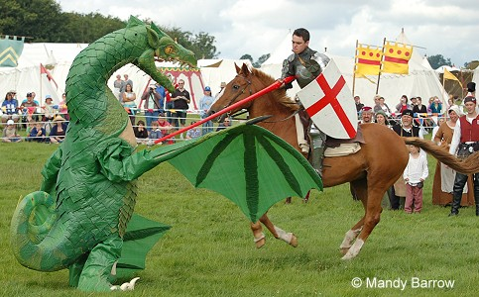
The dragon's scales were so hard that the spear broke into a thousand pieces. and St. George fell from his horse. Fortunately he rolled under an enchanted orange tree against which poison could not prevail, so that the venomous dragon was unable to hurt him. Within a few minutes he had recovered his strength and was able to fight again.
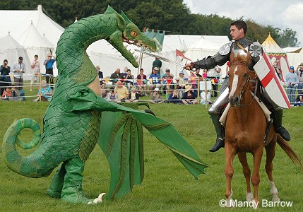
He smote the beast with his sword, but the dragon poured poison on him and his armour split in two. Once more he refreshed himself from the orange tree and then, with his sword in his hand, he rushed at the dragon and pierced it under the wing where there were no scales, so that it fell dead at his feet.

